Please join us for the
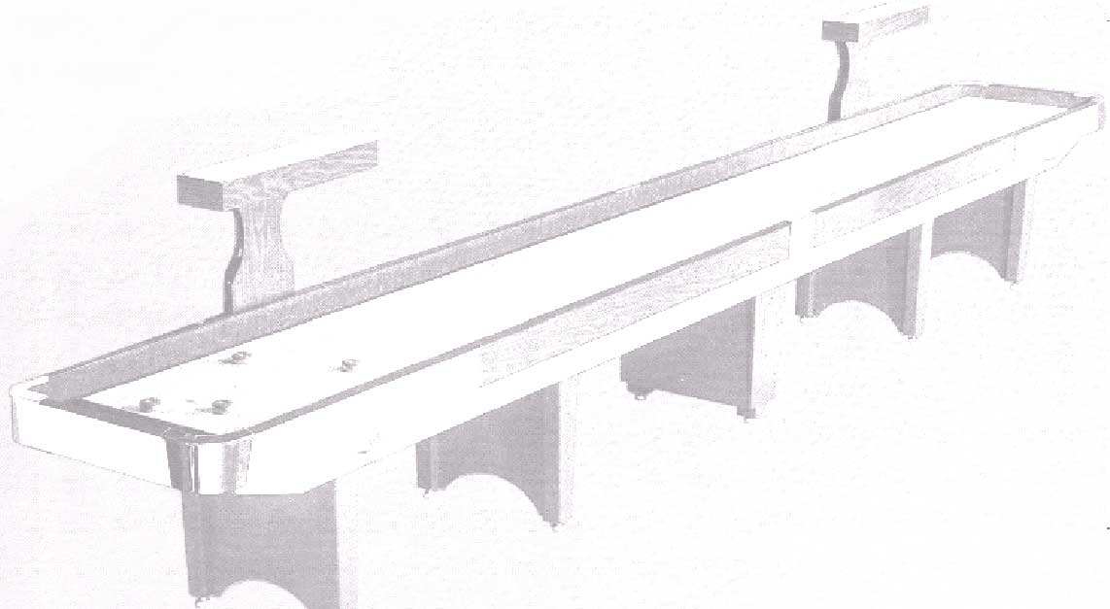
6th Annual Columbus Day
Shuffleboard Tournament
at
Ulena’s Sports Bar

5412 Ulena ~ St. Louis, MO 63116
(314) 352-7969

2 board event

Friday, October 6, 2006 at 7:00 p.m. (Open Draw)

Saturday, October 7, 2006 at 11:00 a.m.

Bring Partner ~ Double Elimination

Handicapped Tournament

Entry Fee $40.00 per team
$5 per person registration fee
(Times may change at promoter’s discretion. Seeding will
be limited. Registration requested by September 29, 2006.)

Motel Options: (AAA & AARP discounts available as well):

4 ½ Miles from bar:
Holiday Inn, I-44 & Hampton,
(314) 645-0700
Red Roof Inn, I-44 & Hampton,
(314) 647-6081
10 Miles from bar:
Motel 6, I-55 & Lindbergh area,
(314) 892-3664
Oak Grove Inn, I-55 & Lindbergh,
(314) 894-9449

To register or for any questions, contact
Jack Murphy (314) 644-4612 – jmurphy1128@sbcglobal.net

