State of Michigan Shuffleboard Championships
Nov. 25th, 26th, 27th

Play on 5 Boards

Schedule of Events

*Friday Nov. 25th- Mixed Doubles:
*Mixed Doubles: $20.00 per player
*Sign-up at 12:00. Sale at 12:30, play following, Double Elimination.

*Saturday Nov. 26th - Open Singles; Ladies Singles; Div. II Singles:
*Open Singles: $40.00 Entry
*Ladies Singles: $20.00 Entry
*Division II Singles: $20.00 Entry
*Played at same time, on first available board, Sign-up at 9 a.m., sale 9:30, play following…

*Sunday Nov. 27th - Open Doubles & Division II Doubles:
*Open Doubles: Progressive Entry, -1’s $40.00, 0’s $30.00, 1’s $20.00, 2’s thru 4’s $10.00
*Div II Doubles: $20.00 Entry (NO 1’s) 2’s 3’s 4’s ONLY!
*Sign-up at Noon. Sale 12:30, play following...

*One time registration fee of $10.00 for all three days’ events,
FREE FEED ON SATURDAY!
Open Thanksgiving for practice and round robins.

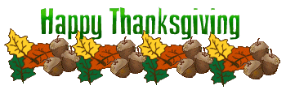

KANES CLUB CAR LOUNGE
111 N. SAGINAW DURAND, MI
(11 MILES WEST OF FLINT ON HWY 69, EXIT 118 TO DOWNTOWN)

FOR TOURNAMENT INFO AND LODGING INFO CALL CLUB CAR @ 989-288-9910

