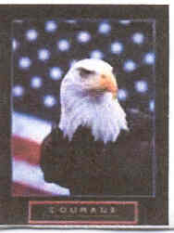

MEMORIAL DAY TOURNAMENT

May 25 – 29, 2006
133 Club
133 W. Yosemite, Manteca, CA

Host – John Azevedo

George Camara induction into the
California Shuffleboard Hall of Fame

Thursday, May 25 A/B Draw $25 ea
5 - 6:00 pm Registration Single game – double elimination
No sponsor sale Ratings: 1.0 – 4, add to 3
6:30 Begin play

Friday, May 26 Pro/Am ABC $25 ea
5-6:00 pm Registration 2 out of 3 / double elimination
6:00 pm Sponsor sale All ratings
7:00 pm Begin play

Saturday, May 27 Open Pro Doubles $200 team
9:00 am Registration Bring Partner
10:00 am Sponsor sale 2 out of 3 / double elimination
11:00 am Begin play All ratings
3:00 pm George Camara Induction Ceremony
5:00 pm Barbeque and continue Doubles

Sunday, May 28 Open Pro Singles $200 ea
9:00 am Registration 2 out of 3/ double elimination
10:00 am Sponsor sale
11:00 am Begin play

Monday, May 29 (10:00am) Open Pro Singles concludes

Tournament registration fee = $25.00
(If playing A/B Draw ONLY – Registration fee = $10.00)
Contact: Rick Thomas (209) 351-0604 tomkat44@comcast.net
Dave Keithahan (408) 891-0952
Dan Mourgos (650) 400-0605

