LONGBOARD TOURNAMENT
CANADIAN MASTERS
August 17 - 20, 2006

AT: Royal Canadian Legion #83
$2,000 +
Added

(604) 434-3534
5289 Grimmer St., Burnaby

SCHEDULE OF EVENTS:
 | EVENT | EVENT TIMES | ENTRY FEE | WHO CAN PLAY
 | A-B-C  Draw Team | Start: Thurs. Aug. 17 @ 6:30 pm  Continues: Fri. Aug.18 @10 am | $20 per player | All
Played Same Time | Singles | Start: Fri. Aug. 18 @ 6:30 pm  Continues: Sat. Aug. 19 @ 11 am | Graduated Entry:  $50 per player  $25 per player  & Sale | All  -1 thru 1  2 thru 5
Played Same Time | Ladies  Doubles | Start: Fri. Aug. 18 @6:30 pm  Continues: Sat. Aug. 19 @ 11 am | $50 per team & Sale | Ladies  -1 thru 5
Played Same Time | Division I  Doubles | Start: Sat. Aug. 19 @6:30 pm  Continues: Sun. Aug. 20 @ 11 am | $100 per team & Sale | All
 | Division II  Doubles | Start: Sat. Aug. 19 @6:30 pm  Continues: Sun. Aug. 20 @ 11 am | $50 per team & Sale | 2 thru 5

All entries in Canadian funds
Play will be under the Bowers Rating System
Payout of entry money (90% players - 10% expenses)
100% payout of sale monies
GREAT CANADIAN HOSPITALITY!
See Reverse for Accommodations and Map

All Players Welcome
from
Across Canada
and the United States

ACCOMMODATIONS:

Best Western Kings Inn 604-438-1383
5411 Kingsway, Burnaby Restaurant and Bar @ hotel
(Currently arranging group rate – more information to follow.)

Inter-City Motel 604-437-4474
Looking into RV Parking
6205 Kingsway, Burnaby

MAP: Royal Canadian Legion #83:
5289 Grimmer Street, Burnaby (604) 434-3534

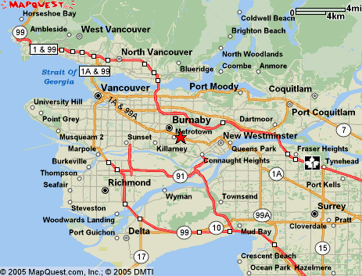
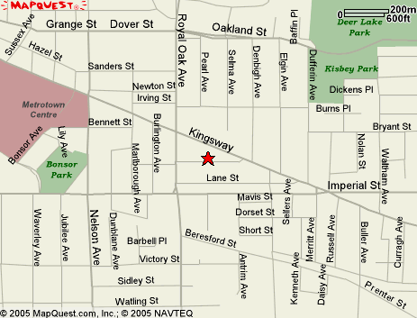

CONTACTS:
Gordie Smith @604-931-7283 email: gordie@eagleshuffleboard.com
Marty Atkinson/Elaine Hill @604-591-5057 email: ehill@telus.net

