LONGBOARD TOURNAMENT
CANADIAN OPEN
Working on more added $$
August 18 - 21, 2005

AT: Royal Canadian Legion #83
$2,000 Guaranteed
Prize $$ Added
Includes $200 added by Lagging4s
(604) 433-9121
5289 Grimmer St., Burnaby

SCHEDULE OF EVENTS:
 | EVENT | EVENT TIMES | ENTRY FEE | WHO CAN PLAY
 | A-B-C  Draw Team | Start: Thurs. Aug. 18 @ 6:30 pm  Continues: Fri. Aug.19 @10 am | $20 per player | All
Played Same Time | Singles | Start: Fri. Aug. 19 @ 6:30 pm  Continues: Sat. Aug. 20 @ 11 am | Graduated Entry:  $50 per player  $25 per player  & Sale | All  -1 thru 1  2 thru 5
Played Same Time | Ladies  Doubles | Start: Fri. Aug. 19 @6:30 pm  Continues: Sat. Aug. 20 @ 11 am | $50 per team & Sale | Ladies  -1 thru 5
Played Same Time | Division I  Doubles | Start: Sat. Aug. 20 @6:30 pm  Continues: Sun. Aug. 21 @ 11 am | $100 per team & Sale | All
 | Division II  Doubles | Start: Sat. Aug. 20 @6:30 pm  Continues: Sun. Aug. 21 @ 11 am | $50 per team & Sale | 2 thru 5

All entries in Canadian funds
Play will be under the Bowers Rating System
Payout of entry money (90% players - 10% expenses)
100% payout of sale monies ESA Rules
GREAT CANADIAN HOSPITALITY!
See Reverse for Accommodations and Map

All Players Welcome
from
Across Canada
and the United States

ACCOMMODATIONS:

Best Western Kings Inn 604-438-1383
RV Parking
@
Legion
5411 Kingsway, Burnaby Restaurant and
Single Room $89 + tax Bar @ hotel
Double (2 beds) $99 + tax

Inter-City Motel 604-437-4474
6205 Kingsway, Burnaby Lots of restaurants in area i.e.
Single Room $65 + tax White Spot, Church's, Wendy's, Italian,
Double (2 beds) $70 + tax Chinese, etc.

MAP: Royal Canadian Legion #83, 5289 Grimmer Street, Burnaby
(604) 433-9121

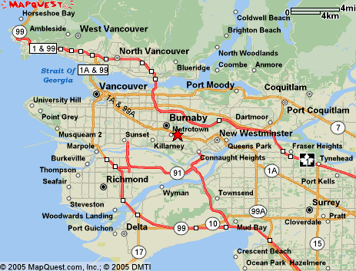
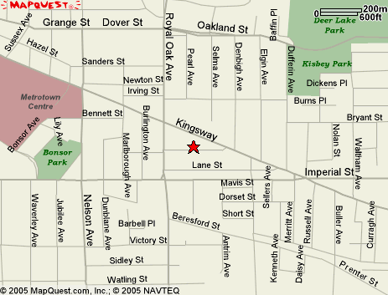

CONTACTS:
Gordie Smith @604-931-7283 email gordie@eagleshuffleboard.com
Brian/Lorraine @ 604-987-7719 or 604-767-0501 email lburchynsky@boughton.ca

