Black Gold Sports Bar
10132 Crowley Rd. Ft Worth, TX 817-293-6520

Handicap Shuffleboard Tournament
August 11th-14th

Thursday, August 11th Open Draw Partner 7PM $30
No Pros or 0’s may draw. Single game, dbl elimination

Friday, August 12th Handicap Singles 7PM
-1s, 0s, and 1s - $50 entry Single game, dbl elimination
2s, 3s, 4s - $30 entry Single game, dbl elimination

Saturday, August 13th Handicap Bring Partner 3PM $30/player
2/3 in winners bracket if time allows
Pros must play with a 1 or above.

Black Gold is a beautiful new 10,000 sq ft. facility owned and operated by fellow shuffler Rob Houchin.

All events are Negative Handicap, Maximum 4 Points.
$10 Registration Fee
8 great boards
For more information about events or nearby hotels contact David Williams 817-707-2850 or Jeri and Bobby Williams 817-657-7306 or Rob Houchin 817-293-6520

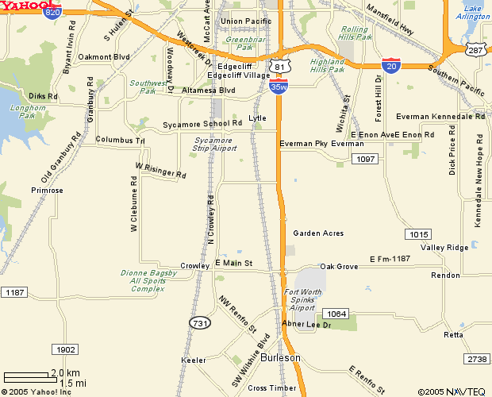
Black Gold Sports Bar - from I-35W take Risinger Rd exit, turn west, at Crowley Rd. turn left. Black Gold is on the Right about ½ mile. From I-20 take Crowley Rd, go south about 5 miles. Black Gold is on the right.

Howard Johnson Inn - $59 a night. 817-447-2000, 12250S Fwy. About 4 mile from Black Gold. – take a left onto Crowley Rd., right onto Risinger, right at I-35, hotel is on the service road. Rooms reserved at this price until 7/31.

Risinger Rd

