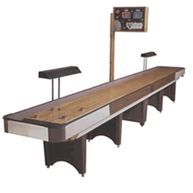
"COME ONE COME ALL"
BZ'S APRIL TOURNEY
A/B B.Y.O.P. (player)
4/21/06 -4/23/06
FRIDAY NIGHT $10.00 A/B DRAW
SINGLE ELIMINATION SIGN
UP BY 6:30 PLAY@ 7:00
SATURDAY THE 22ND
$50.00 TEAMS A/B B.Y.O.P. (player)
SIGN UPS UNTIL 10:30 AM
11:30 AM SPONSER SALE
PLAY TO FOLLOW
THIS IS PAUL'S FIRST
"RUNN'IN OF THE PUCKS"
SO COME ON OUT'N PLAY
TOURNEY DIRECTOR PAUL
INFO (206) 351-3013 email proush@mybluelight.com
or Cheri (206) 234-1526

