1st Annual Greater Detroit Open

Shuffleboard Tournament

April 29-May 1, 2005

Host: Jason Papa

Madison Park Bar & Grill

25023 John R. Road

Madison Heights, MI 48071

Madison Park Bar & Grill

Play on 3 Ambassador Shuffleboards --- 3 Great Events --- One-Time $10 Registration Fee
--- Current Bowers’ Ratings Used in all 3 Events ---
--- Note: Any Unrated Player(s) Will Be Rated By the Tournament Committee ---

Friday, April 29th: A-B Round Robins

- Start @ 8pm and go all night until last call!!
- $10 Entry Fee per Round Robin…$100 Added To Each Pot

Saturday, April 30th: Open & Div II Singles

- Registration starts @ 10am. Auction starts @ Noon.
- Play to Begin Immediately Following the Auction in both events
- Single Game – Double Elimination
- Entry Fee: $30 Open Division, per player - $20 Division II, per player

Sunday, May 1st: Open & Div II Doubles

- Registration starts @ 11am. Auction starts @ Noon.
- Single Game – Double Elimination
- Entry Fee: $30 Open Division, per player - $20 Division II, per player

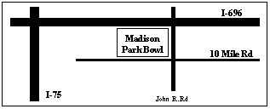
For More Information,
Contact Jason Papa @ 248-541-9305
Or
CoCo Brown @ 586-924-4952

Tournament Committee:
Jason Papa, CoCo Brown, Rob Kern

