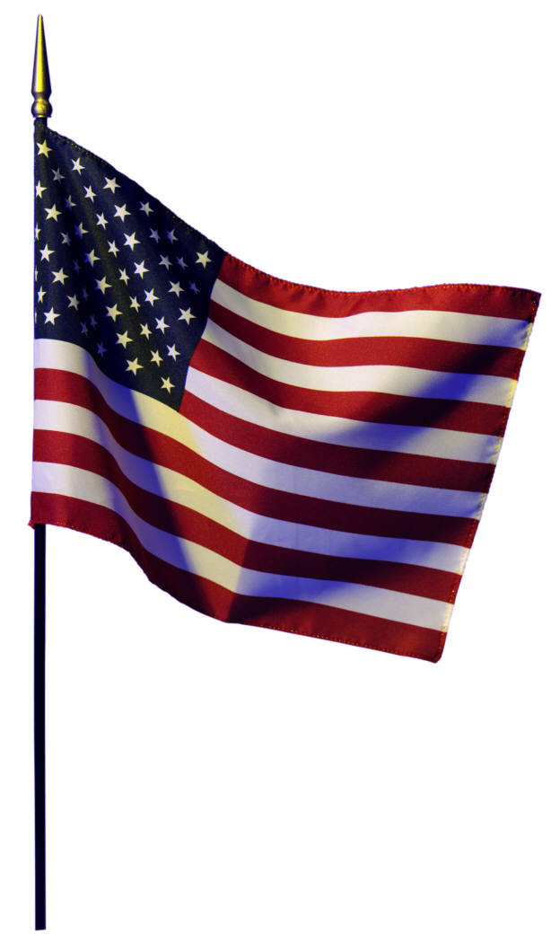Annual 4th of July
Shuffleboard Tournament

Hurricane’s Hide-A-Way
1297 Flower Lane, Grants Pass, Oregon

Wednesday, July 2, 2014 – Sunday, July 6, 2014

Reg. Fee - Covers food (2 days) , wax, certificates $ 25 pp

Tues - Early Bird - open play and Round Robins

Wed - A/B Draw Doubles $ 20 pp
10:00 am Double elimination – 15 pt game

Thurs/Fri - Open Singles $100 pp
10:00 am 2 out of 3 winners and 21 pt losers bracket

Div I Bring Partner (add to 3) $ 50 pp

Div II Bring Partner (add to 6) $ 25 pp

Sat/Sun - 4-Person Draft Team $ 25 pp
10:00 am

July 4th & July 5th – Barbeque

Some beds available (call for availability) and RV parking some with hook-ups available (first come first serve) plus all Grants Pass hotels are within 5 miles of property.
There will be 4 to 6 boards available for play.

Contact information: Lorraine Olson cell phone (541) 441-2700
e-mail: hurricanelorraine@msn.com

