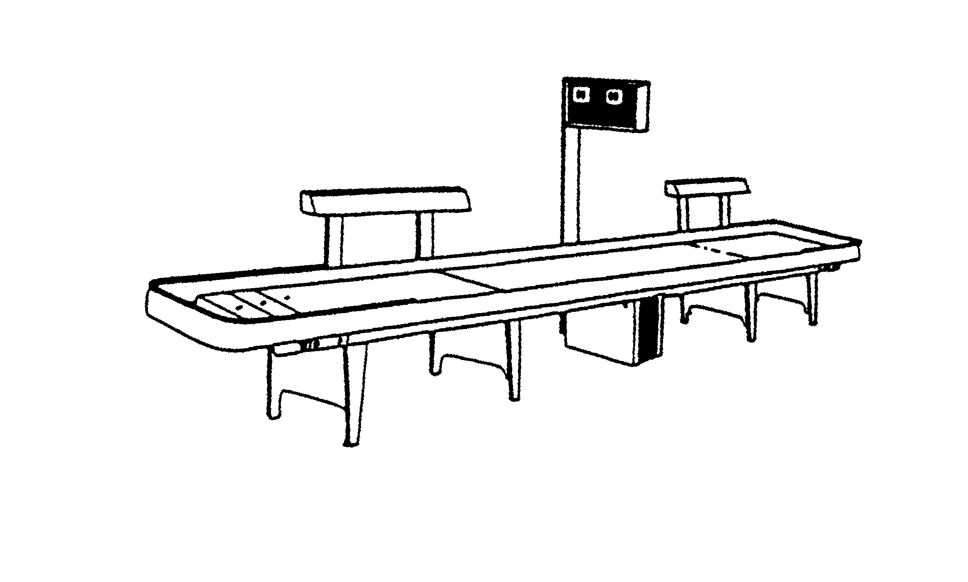
EVERGREEN PACIFIC NORTHWEST
2006 TOURAMENT SCHEDULE
(OREGON & WASHINGTON)
January 06  27-29 Buzz’s Mud Bay  Masters | February 06  10-12 Blue Goose Sweethearts Mixed Doubles  16-20 Presidents Day Multiple/Eagles, Medford  24-26 Fircone Tavern Masters Tournament | March 06  11-12 2nd Annual 4 Person Pro-Am Draft  Glasscock’s Cadillac Ranch, Gold Hill  17-19 Nifty Fifty’s  A/B Bring Your Own
April 06  7-9 Red Dog ABC Draw  Larry Hudson Memorial Tournament  21-23 BZ’S Sports Bar  A/B Bring your Own | May 06  6-7 34th Annual Eagles Doubles/Eagles, Medford  12-14 Mud Bay Mixed Doubles Tournament  24-29 Season Ticket Memorial Day Tournament Multi-Event | June 06  2-4 Fircone Tavern  “Forest Festival” A/B  Bring Your Own  9-11 A/B Doubles (Bring Your Own) Goonies, Coos Bay, OR  24-25 Tim’s Timber  A/B “Bring Your Own” Tournament  24th - 25th Whistling Oyster Bar  “Tournament Of Champions” - Doubles –CALL FOR DETAILS…  “ MUST HAVE QUALIFIED TO PLAY’ CONTACT: Sandee & Bill Vanwagenen@worldfront.com  or call 1-360-765-9508 (Bar) 1-360-765-3436 (Home)
July 06  14-16 6th Annual A/B Doubles (Bring) Cattlemen’s  Rogue River, Oregon | August 06  3-6 Whistling Oyster  Multi Event  17-20 Canadian Longboard Masters 2006/Multi Event  Royal Canadian Legion Branch #83  Burnaby, BC Canada  (Flyer coming soon!) | September 06  31-3 EAGLES LODGE  MEDFORD, OREGON  Multi Event Tournament  22-24 Mud Bay/Buzz’s  Jack Steffensen Memorial Tournament) Multi-Event
October 06  30-1 3rd Annual A/B/C Draft Glasscock’s Cadillac Ranch, Gold Hill  13-15 American Legion Kelso, WA  Format TBD  29-6 RENO NASC | November 06  10-12 Ernie’s Fircone Mixed Doubles Tournament  24-26 BZ’S ABC Draw  Thanksgiving Tourney  25th 4th Annual 3-Person  (Bring) Eagles, Medford  *Limit 1 *A* Player | December 06  29-31 Tim’s Timber  A/B “ Bring Your Own”
** Oregon Tournaments **Washington Tournaments

** ANY QUESTIONS OR UPDATES CONTACT SHARON NUGENT @ 253-576-6341 or at tweetybird-121@comcast.net

